The Beginning
Coordinated Entry began in 2016 as an effort to make the housing process for equitable and accessible for people experiencing a housing crisis or homelessness. Each county adapted Coordinated Entry on their own timeline, first the SMAC counties, then Ramsey, and then Hennepin.

Coordinated Entry is a HUD mandate
Housing and Urban Development (HUD) mandated that communities receiving HUD dollars would implement a coordinated process to assess clients and refer them to housing services.

Continuums of Care
The state was divided into Continuums of Care (CoC’s). Hennepin formed one CoC, Ramsey formed another while Scott, Carver, Dakota, Washington and Anoka counties formed the SMAC CoC. Every CoC built their CE systems separately and on different timelines
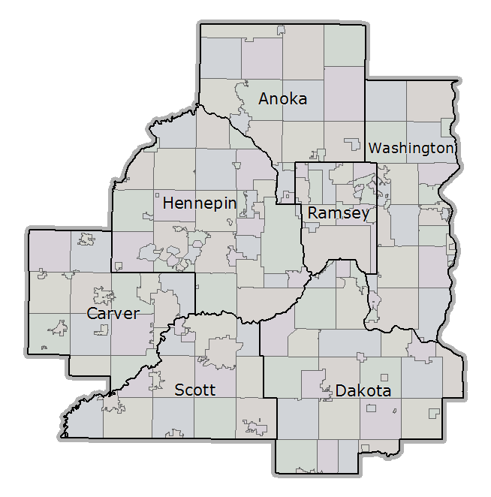
Before Coordinated Entry
- Client applied directly to each program
- Programs had different application processes
- Programs operated in silos, with less accountability and with little transparency
- How we did the work determined how we saw the population, our barriers often made clients invisible

After Coordinated Entry
- Client applies once, and applies to all the programs in their community
- Application process is streamlined, simplified and more accessible
- Referrals based on an objective set of criteria (no longer able to take just housing ready clients).
- Coordinated entry creates a community wide approach, increases accountability and transparency for clients, service providers, and advocates
- We have a better picture of the housing needs of the community, our own effectiveness, and the gaps of services.

Contacting your Continuum of Care Coordinators
Hennepin: CES.hennepin@hennepin.us
Ramsey: Loni Aadalen, loni.aadalen@CO.RAMSEY.MN.US
SMAC: Abby Guilford, abby@mesh-mn.org

Being Trauma Informed during the assessment
Asking about
- Sexual Exploitation
- Domestic Violence.
- Mental Health
- Chemical Dependency
Some advice…
- Be empathetic
- Thank the client for sharing their experience with you
- Openly acknowledge how difficult and retraumatizing it can be to talk about their experience
- Be ready to support this person with relevant resources in the community

How to describe Coordinated Entry
Create a 30 second speech summarizing the basic process of Coordinated Entry. The better a person understands the process, the more they invest in it.
Here are some talking points to include:
- Housing is not immediate or guaranteed
- Coordinated Entry connects you to subsidized housing
- The assessment process is invasive and includes many personal questions
- The wait time may be long, please continue to work on other housing options
- Describe the importance of staying in contact with assessor and providing updates.
Describing Releases of Information
- Not everyone reads everything they commit their signature to it.
- Get to know your needed releases of information so that you can summarize what they are and why they are needed to your clients so they may make an informed decision about what they are signing and disclosing.
How to Close your meeting
How you end the meeting with your client will prepare them for what to do next.
Here are some closing conversation pointers to include in your wrap up.
- What did they score? Describe what this type of housing is
- Are they move-in ready? Talk about what documentation they may need.
- Are they currently in need of shelter or assistance? Connect them with resources.
- Describe the importance of keeping you updated on their information
- Explain the importance of continuing to work on additional housing solutions
- Thank your client for sharing their life and their experience with you. Acknowledge the difficulty and the invasive nature of the assessment.
SMAC MN
Suburban Metro Area
Continuum of care

